**Ryan Laur**

**Benjamin Wheeler  
2/21/2022**

**Report – Lab 1**

Figure 1 - FSMD 1-Process Modelsim, showing no errors 2

Figure 2 - FSMD 2-Process Modelsim, showing no errors 2

Figure 3 - FSM + D Modelsim, showing no errors 3

Figure 4 - FSM 1-Process Quartus, showing no errors 3

Figure 5 - FSM 2-Process Quartus, showing no errors 3

Figure 6 - FSM + D Quartus, showing no errors 4

Figure 7 - Datapath Schematic 5

Figure 1 - FSMD 1-Process Modelsim, showing no errors

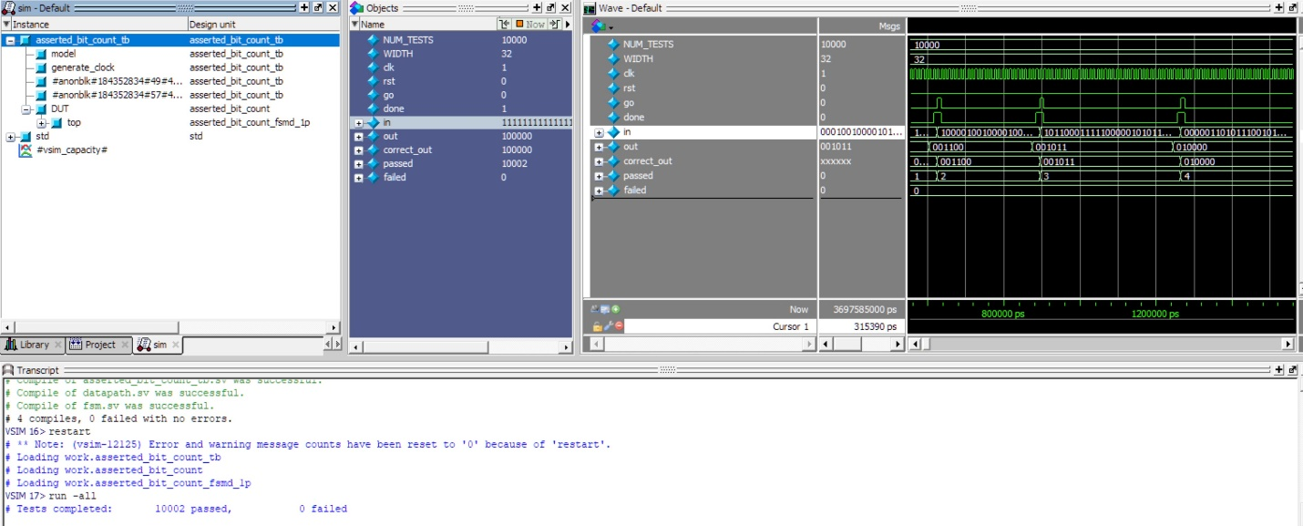

Figure 2 - FSMD 2-Process Modelsim, showing no errors

Figure 3 - FSM + D Modelsim, showing no errors

Figure 4 - FSM 1-Process Quartus, showing no errors

Figure 5 - FSM 2-Process Quartus, showing no errors

Figure 6 - FSM + D Quartus, showing no errors

Figure 7 - Datapath Schematic

